|  |  |  |  |  |  |  |
| --- | --- | --- | --- | --- | --- | --- |
| **Practicum Final Exam – Odd Semester Year 2021/2022** | | | | | | |
| **Subject** | | | **COMP6047 – Algorithm and Programming** | | |  |
| **Class** | **:** | **09AB** | | **Start Date** | **: 03 December 2021** |
| **Lecturer** | **:** | **D5337 - Yudy Purnama, S.Kom, M.TI** | | **Start Time** | **: 08.00** |
| **End Date** | **: 03 December 2021** |
| **End Time** | **: 10.00** |

**PERATURAN UJIAN:**

*Exam Regulations:*

* Mahasiswa tidak diperbolehkan berdiskusi dan/atau bekerja sama dengan peserta ujian lainnya

*Student is not allowed to discuss and/or work together with other exam participants*

* Mahasiswa tidak diperbolehkan untuk membuka dan menyalin dari **BUKU** atau **CATATAN**, **VIDEO** dari pengajar (recording kelas, VBL, Youtube, dsb) dan **REFERENSI** lainnya

*Student isn't allowed to open and copy from any resources such as notes, videos (class recording, VBL, Youtube, etc) and other references*

* Mahasiswa tidak diperbolehkan membuka dan menyalin jawaban dari internet (google, stackoverflow, dsb)

*Student isn't allowed to open and copy answer from the internet (google, stackoverflow, etc)*

* Asisten **BERHAK** memberi nilai 0 **(NOL)** bagi peserta ujian yang melakukan segala bentuk kecurangan

*Assistant is able to give 0 (ZERO) score for exam participant who does any cheating actions*

* Kumpulkan jawaban tepat pada waktunya, apabila terlambat mengumpulkan maka jawaban tidak akan dikoreksi dan nilai mahasiswa adalah 0

*Submit the answer on time, if not, then the answer will not be checked, and the students will receive 0 (ZERO)*

* Bila Anda tidak membaca peraturan ini, maka Anda dianggap telah membaca dan menyetujuinya

*If you have missed to read these regulations, so you are considered to have read and agreed on it*

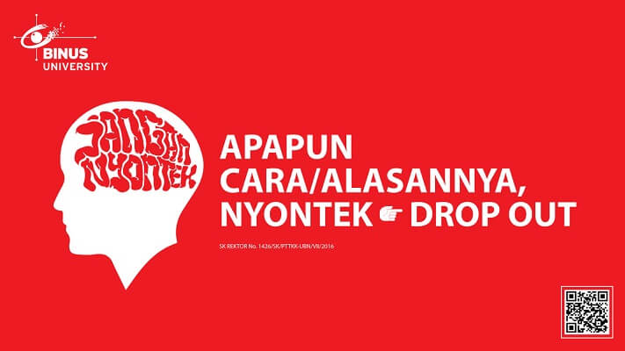

**SOFTWARE YANG DIGUNAKAN:**

*Software will be used:*

* Dev-C++ 5.11

**FILE YANG DIKUMPULKAN:**

*File must be collected:*

* CPP

**PERHATIAN!**

*Attention!*

* Bagi yang mengerjakan tidak sesuai dengan soal, maka akan diberikan nilai **NOL (0)**

*For those who do not work in accordance with the exam case will be marked as* ***ZERO (0)***

* Bagi yang mengerjakan tidak sesuai dengan software dan versi yang telah ditetapkan, maka akan tetap dikoreksi dengan software dan versi yang telah ditetapkan

*For those who do not work in accordance with the software and specific version will be corrected by the predefined software and version*

* Kompres semua jawaban yang akan diunggah. Pastikan format pengumpulan nama file dan ekstensi sesuai dengan format berikut: **[NIM]-[NAMA].zip**

*Compress all file that will be uploaded. Make sure the format for collecting file name and extension according to the following format:* ***[NIM]-[NAME].zip***

**Important Notes:**

1. Do not code only on the main function, **each menu must be separated into a separate function**
2. You **need** to use **Merge Sort/ Quick Sort Algorithm**
3. You are **allowed** using a **struct** to store all your variable that needed

**Soal**

*Case*

**Random Fried Rice Shop**

**Christina**, the owner of the **Random Fried Rice Shop** likes pseudorandom, so she wants to implement it to her restaurant. She asked you to develop a program using **C Programming Language** to help her based on the description below:

* In the first time, the program will **read the file** which the **name** is ‘***data.csv***’ using the following format:

|  |
| --- |
| **CustomerName#FriedRiceName#Topping#Price#Quantity** |

* If the file does not exist, **do not insert any data**.
* If the file exists, but there are no content inside it, **do not** **insert any data**.
* If the file exists and there are contents inside the file, **insert the data** and stored it in **an array**.
* The program consists of **4 menus**:

1. Insert Order
2. View Order
3. Delete Order
4. Exit

Figure 1. Menu

* The program will ask the user to input the **chooses menu**, which must be **between 1** and **4**

Figure 2. Menu Validation

Figure 3. Menu Validation

* If the user chooses **menu** **1** (‘**Insert Order**’), then:
* The program will ask the user to input **menu details**, which consists of:
* **Customer Name**, which must be **between 3** and **50 characters**
* **Fried Rice Type**, which must be **between 1** and **4**
* **Fried Rice Topping**, which must be **between 1** and **3**
* **Quantity**, which must be **between 1** and **10**
* If the inputs are valid, **generate Random Price** using following formula:

|  |
| --- |
| **Price = (Random between 1 and length of customer name) * 7000** |

Figure 4. Price Formula

Figure 5. Insert Menu

* If the user chooses **menu** **2** (‘**View Order**), then:
* If there are no data, simply display there are no data

Figure 6. No Data Message

* This menu will view all the order and the program will **ask** for an **input between** **1** and **4**

Figure 7. View menu

* If the user chooses menu **1**, **sort the data** based on **individual price** of the **fried rice**
* If the user chooses menu **2**, **sort the data** based on **quantity**
* If the user chooses menu **3**, **sort the data** based on **customer name**
* If the user chooses menu **4**, simply exit to the main menu

Figure 8. Ordered by Price

Figure 9. Ordered by Quantity

Figure 10. Ordered by Customer Name

* If the user chooses **menu** **3** (‘**Delete Order**’), then:
* If there are no data, simply display there are no data

Figure 11. Trying to Delete a File with no Data

* If there are any data, the program will **ask for input** **between 1** and **total data**, the **chosen data** will be **deleted** by the **program**
* After deletion, add the multiplication of price and quantity into **current money**.

Figure 12. Delete data

Figure 13. After Deletion

Figure 14. After Deletion

* If the user chooses **menu** **4** (‘**Exit**’), then:
* The program will **save** the menu list to the **file** which the **name** is ‘***data.csv***’ using the following format:

|  |
| --- |
| **CustomerName#FriedRiceName#Topping#Price#Quantity** |

* After that, the program will be closed

**Run the program for more details!**